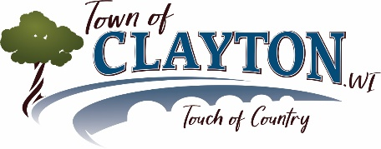 Election Inspectors FAQs

What is an Election Inspector?

Election Inspectors (aka Poll Workers) staff the polls on Election Day to ensure voters are able to exercise their right to vote in an honest and well-organized manner.

Who can be an Election Inspector?

You are eligible to be an Election Inspector if you are:
- A U.S. citizen
- A citizen of Winnebago County
- At least 18 years of age
- Student 16 or 17 years of age (additional requirements)

When are Election Days and what are the hours?

Spring Primary Elections are held the 3rd Tuesday in February (if necessary)
Spring Elections are held the 1st Tuesday in April
Presidential Preference Elections are held the 1st Tuesday in April (every 4 years)
Fall Primary Elections are held the 2nd Tuesday in August (if necessary)
Fall General Elections are held the 1st Tuesday in November (even numbered years)
Presidential Elections are held the 1st Tuesday in November (even numbered years)
- Polls are open from 7:00 a.m. through 8:00 p.m.
- The Town of Clayton utilizes split shifts with staggered start/end times

What type of people work as Election Inspectors?

Anyone! We have a diverse group of individuals, from many different backgrounds. We are always looking for new people to join the group.

Are Election Inspectors trained?

Yes. At a minimum, a 1.5-hour training session is held prior to each election with the Town Clerk.

Are Elections Inspectors paid?

Inspectors may choose to be paid or to volunteer their time.

How do I apply to be an Election Inspector?

Contact the Town office or visit the Town’s website, www.townofclayton.net, for an application. Complete the application and return it to the Town office. Election Inspectors are asked to serve for two-year terms, with the opportunity to reapply with each new term.

Once approved, you may be required to complete additional hiring paperwork and you will take an Oath of Office.

What are Election Day requirements?

- You must attend a training session prior to working an election
- The polling place must be open for voting between the hours of 7:00 am and 8:00 pm
- You will be scheduled for a specific shift and will be required to complete a timesheet for each election
- Opening shift assists in the final set-up of the Polling Place
- Closing shift assists in the closing of the Polls and complete all required paperwork required of the Municipal Board of Canvas

What are the main Election Day activities?

- Help voters with Election Day Registrations
- Processing voters in the Poll Books
- Assigning voter numbers
- Handing out ballots
- Tallying ballots, specifically write-in votes, as needed
- Completing Election Day forms
- Processing Absentee Ballots
- Processing Provisional Ballots
- Processing any Voter Challenges
- Transmitting Voting Machine data to the Winnebago County Clerk
- Compiling data and forms for submission to the Town of Clayton, the Winnebago County Clerk, and School Districts (if applicable).

